DISCLOSURE FORM

Date: 10.02.2024

Name: Virchow, Johann Christian

Professional details: Physician, University of Rosotck, Germany
Main occupation and employing organisation:

Event: 1st Asian Chapter of the International Workshop on Lung Health

Provider organisation: Publi Créations S.A.M. and Lena Events and Communication

Date of event: 23/02/2024 – 25/02/2024

Please declare any interests here relating to the 36 months prior to the event:

Commercial
J. C. Virchow has
  - participated in advisory boards and provided independent advice for
    - Avontec, Boehringer-Ingelheim, Cypla, Chiesi, Essex/Schering-Plough, Genzyme, GSK, Janssen-Cilag, MEDA, MSD, Mundipharma, Novartis, Regeneron, Revotar, Roche, Sanofi-Aventis, Sandoz-Hexal, TEVA, UCB/Schwarz-Pharma and possibly others

The existence of any significant financial activity or other relationship the speaker or programme planner has with manufacturer(s) of any commercial product and/or providers of commercial services used on or produced for patients these include:

Research grants None

Speaker fees
J.C. Virchow has
  - given independent lectures for and received honoraria from:
    - AstraZeneca, Avontec, Bayer, Bencard, Bionorica, Boehringer-Ingelheim, Chiesi, Cipla, German Remedies, Essex/Schering-Plough, Genzyme, GSK, Janssen-Cilag, Leti, Lupin, MEDA, Merck, MSD, Mundipharma, Noramed, Novartis, Nycomed/Altana, Pfizer, Providens, Regeneron, Revotar, Sandoz-Hexal, Sanofi-Aventis, Stallergens, TEVA, UCB/Schwarz-Pharma, Zydus/Cadila and possibly others

Other educational activities
None

Honoraria or consultation fees
J. C. Virchow has
  - participated in advisory boards and provided independent advice for
    - Avontec, Boehringer-Ingelheim, Cypla, Chiesi, Essex/Schering-Plough, Genzyme, GSK, Janssen-Cilag, MEDA, MSD, Mundipharma, Novartis, Regeneron, Revotar, Roche, Sanofi-Aventis, Sandoz-Hexal, TEVA, UCB/Schwarz-Pharma and possibly others

Ownership of stocks or shares, directorships
None

Any other financial relationship
None

Other conflicts of interest such as expert functions in health care and health guidance processes
No
E.g. Board member in a development project, member of health board in the municipality

Signature: 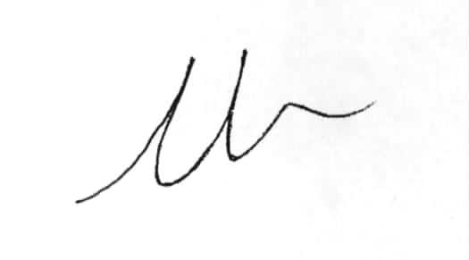 Date: 10.02.2024

