DISCLOSURE FORM

Date: 18th February 2024

Name: Dr Amita Nene

Professional details: Pulmonologist, Bombay Hospital
Institute of Medical Sciences
Main occupation and employing organisation:

Event: 1st Asian Chapter of the International Workshop on Lung Health

Provider organisation: Publi Créations S.A.M. and Lena Events and Communication

Date of event: 23/02/2024 – 25/02/2024

Please declare any interests here relating to the 36 months prior to the event:

Commercial
The existence of any significant financial activity or other relationship the speaker or programme planner has with manufacturer(s) of any commercial product and/or providers of commercial services used on or produced for patients these include:

Research grants - None

Speaker fees - None

Other educational activities

Honoraria or consultation fees - None

Ownership of stocks or shares, directorships - None

Any other financial relationship - No

Other conflicts of interest such as expert functions in health care and health guidance processes - No
E.g. Board member in a development project, member of health board in the municipality
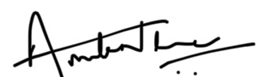

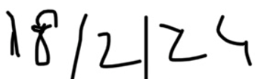

Signature: Date: 18th

