DISCLOSURE FORM

Date: 10.02.2024

Name: Dr. Rakesh K Chawla

Professional details:
Main occupation and employing organisation: HOD & Sr Consultant Department of Respiratory Medicine, Critical Care & Sleep Disorder Jaipur Golden Hospital & Saroj Super Speciality Hospital, Delhi

Event: 1st Asian Chapter of the International Workshop on Lung Health

Provider organisation: Publi Créations S.A.M. and Lena Events and Communication

Date of event: 23/02/2024 – 25/02/2024

Please declare any interests here relating to the 36 months prior to the event:

Commercial
The existence of any significant financial activity or other relationship the speaker or programme planner has with manufacturer(s) of any commercial product and/or providers of commercial services used on or produced for patients these include:

Research grants - NO

Speaker fees - NO

Other educational activities - NO

Honoraria or consultation fees - NO

Ownership of stocks or shares, directorships - NO

Any other financial relationship - NO

Other conflicts of interest such as expert functions in health care and health guidance processes
E.g. Board member in a development project, member of health board in the municipality
Signature: 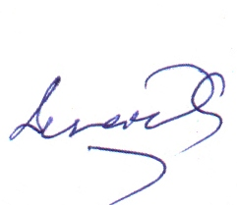 Date: 10.02.2024

