DISCLOSURE FORM

Date: 11-02-2024

Name: Dr.Venkata Nagarjuna Maturu

Professional details: Doctor

Main occupation and employing organisation:

Consultant and Head,
Dept. of Pulmonary Medicine
Yashoda Hospitals, Hitec city
Hyderabad

Event: 1st Asian Chapter of the International Workshop on Lung Health

Provider organisation: Publi Créations S.A.M. and Lena Events and Communication

Date of event: 23/02/2024 – 25/02/2024

Please declare any interests here relating to the 36 months prior to the event:

Commercial
The existence of any significant financial activity or other relationship the speaker or programme planner has with manufacturer(s) of any commercial product and/or providers of commercial services used on or produced for patients these include:

Research grants : NA

Speaker fees: Have received speaker fees for delivering lectures from GSK, Astrazeneca, Cipla, Novartis and Olympus

Other educational activities : NA

Honoraria or consultation fees: NA

Ownership of stocks or shares, directorships: NA

Any other financial relationship : NA

Other conflicts of interest such as expert functions in health care and health guidance processes
E.g. Board member in a development project, member of health board in the municipality

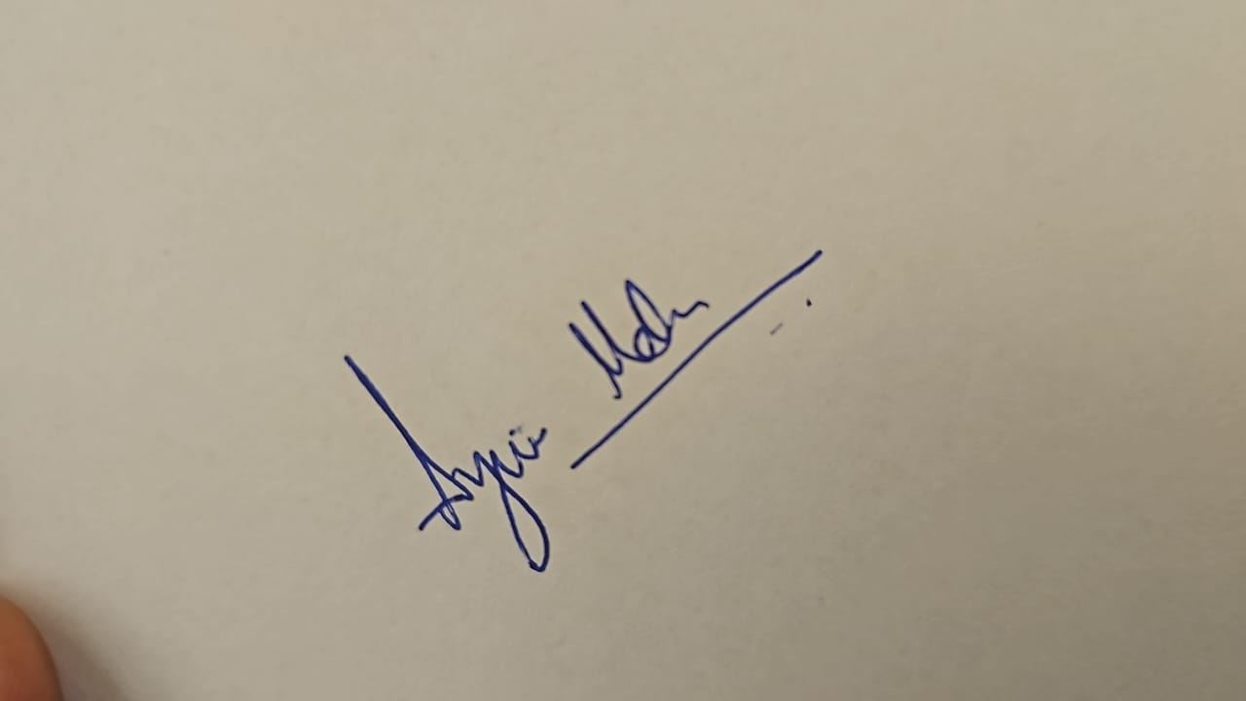
Signature: Date: 11-02-2024

