DISCLOSURE FORM

Date: 21st Nov 2023

Name: Dr Alison J Dicker

Professional details:
Main occupation and employing organisation: Principal Investigator, University of Dundee

Event: 6th Forum on Respiratory Tract Infections

Provider organisation: Lena Events and Communication

Date of event: 05/02/2024 – 07/02/2024

Please declare any interests here relating to the 36 months prior to the event:

Commercial
The existence of any significant financial activity or other relationship the speaker or programme planner has with manufacturer(s) of any commercial product and/or providers of commercial services used on or produced for patients these include:

Research grants None

Speaker fees None

Other educational activities None

Honoraria or consultation fees None

Ownership of stocks or shares, directorships None

Any other financial relationship None

Other conflicts of interest such as expert functions in health care and health guidance processes
E.g. Board member in a development project, member of health board in the municipality

None

Signature: 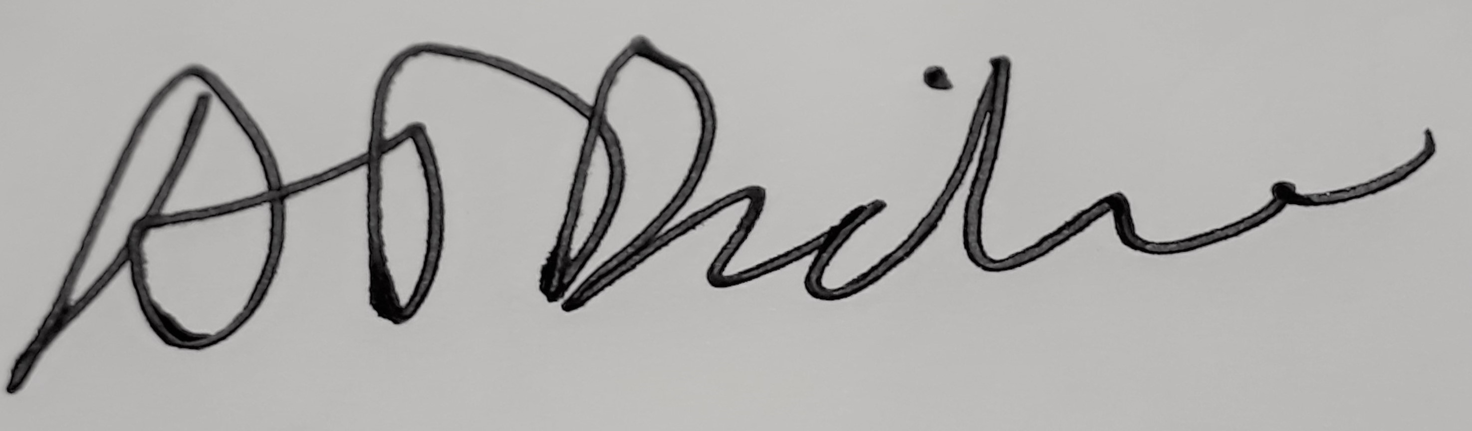 Date: 21st Nov 2023

