Conflict of Interest Disclosure Form
(to be completed by scientific/organising committee members)

NAME: James Chalmers

AFFILIATION: University of Dundee

In accordance with criterion 24 of document UEMS 2012/30 “Accreditation of Live Educational Events by the EACCME”, all declarations of potential or actual conflicts of interest, whether due to a financial or other relationship, must be provided to the EACCME® upon submission of the application. Declarations also must be made readily available, either in printed form, with the programme of the LEE, or on the website of the organiser of the LEE. Declarations must include whether any fee, honorarium or arrangement for re-imbursement of expenses in relation to the LEE has been provided.

DISCLOSURE
q I have no potential conflict of interest to report
X I have the following potential conflict(s) of interest to report
Type of affiliation / financial interest | Name of commercial company
Receipt of grants/research supports: | AstraZeneca, Boehringer Ingelheim, GlaxoSmithKline, Gilead Sciences, Grifols, Novartis, Insmed and Trudell
Receipt of honoraria or consultation fees: | Antabio, AstraZeneca, Boehringer Ingelheim, Chiesi, GlaxoSmithKline, Insmed, Janssen, Novartis, Pfizer, Trudell and Zambon
Participation in a company sponsored speaker’s bureau:
Stock shareholder:
Spouse/partner: | /
Other support (please specify): | /
I assure that my involvement in organizing and defining the scientific programme has not been influenced by any company I have previously and I am collaborating with.

Signature: 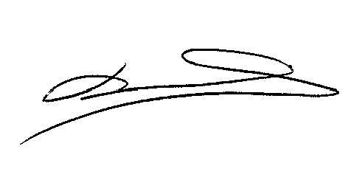 Date: 29-8-23

