**DISCLOSURE FORM**

**Date: 14/11/24**

**Name: Steven Walker**

**Professional details: Consultant**

**Event:** 7th Forum on Respiratory Tract Infections

**Provider organisation:** Lena Events and Communication

**Date of event:** 03/02/2025 – 05/02/2025

**Please declare any interests here relating to the 36 months prior to the event:**

**Commercial**

*The existence of any significant financial activity or other relationship the speaker or programme planner has with manufacturer(s) of any commercial product and/or providers of commercial services used on or produced for patients these include:*

**Research grants**

NIHR

Rocket Medical

**Speaker fees**

Cheisi

**Other educational activities**

None

**Honoraria or consultation fees**

None

**Ownership of stocks or shares, directorships**

None

**Any other financial relationship**

None

**Other conflicts of interest such as expert functions in health care and health guidance processes**

None

**Signature:  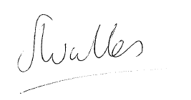 Date: 14/11/24**