DISCLOSURE FORM

Date: 4/12/24

Name: Freddy Frost

Professional details:

Event: 7th Forum on Respiratory Tract Infections

Provider organisation: Lena Events and Communication

Date of event: 03/02/2025 – 05/02/2025

Please declare any interests here relating to the 36 months prior to the event:

Commercial
The existence of any significant financial activity or other relationship the speaker or programme planner has with manufacturer(s) of any commercial product and/or providers of commercial services used on or produced for patients these include:

Research grants: Asthma & Lung UK, Cystic Fibrosis Trust, Lifearc

Speaker fees: Astrazeneca, Chiesi, Vertex,

Other educational activities: Chiesi

Honoraria or consultation fees: Insmed, Astrazeneca

Ownership of stocks or shares, directorships

Any other financial relationship

Other conflicts of interest such as expert functions in health care and health guidance processes
E.g. Board member in a development project, member of health board in the municipality

Signature: 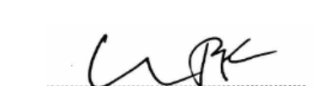 Date: 4/12/24

