**DISCLOSURE FORM**

**Date: 07.01.25**

**Name: David Connell**

**Professional details:**

***Main occupation and employing organisation:***

***Consultant Respiratory Physician***

***Ninewells Hospital***

***NHS Tayside***

**Event:** 7th Forum on Respiratory Tract Infections

**Provider organisation:** Lena Events and Communication

**Date of event:** 03/02/2025 – 05/02/2025

**Please declare any interests here relating to the 36 months prior to the event:**

**Commercial**

*The existence of any significant financial activity or other relationship the speaker or programme planner has with manufacturer(s) of any commercial product and/or providers of commercial services used on or produced for patients these include:*

**Research grants**

**Speaker fees**

**Other educational activities**

**Honoraria or consultation fees**

**I have received Honoraria/Consultation fees from INSMED Ltd., Aztra-Zeneca, GSK**

**Ownership of stocks or shares, directorships**

**Any other financial relationship**

**Other conflicts of interest such as expert functions in health care and health guidance processes**

*E.g. Board member in a development project, member of health board in the municipality*

**Signature:** 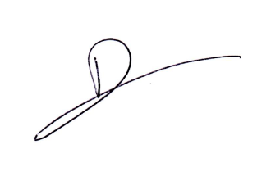

**Date: 07.01.25**